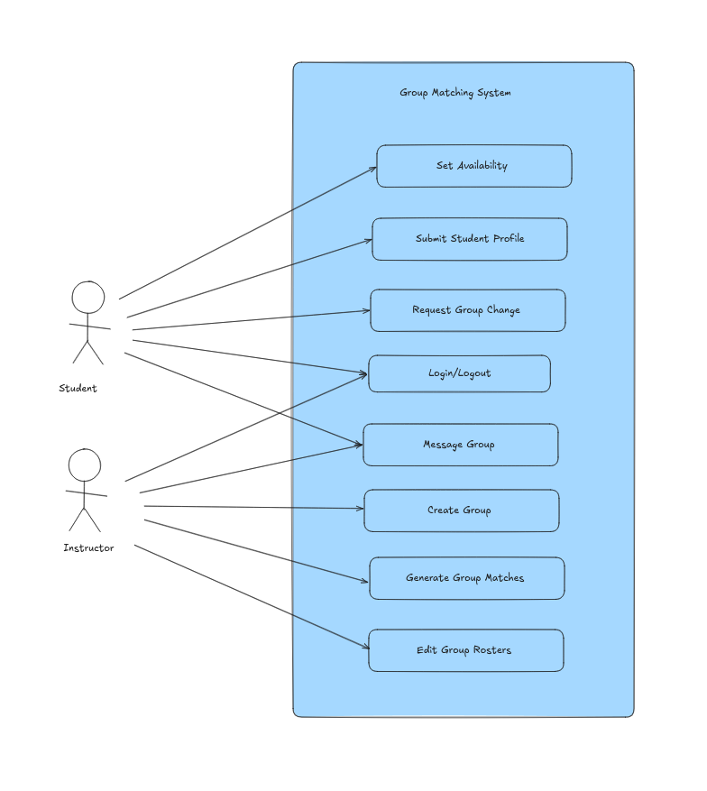
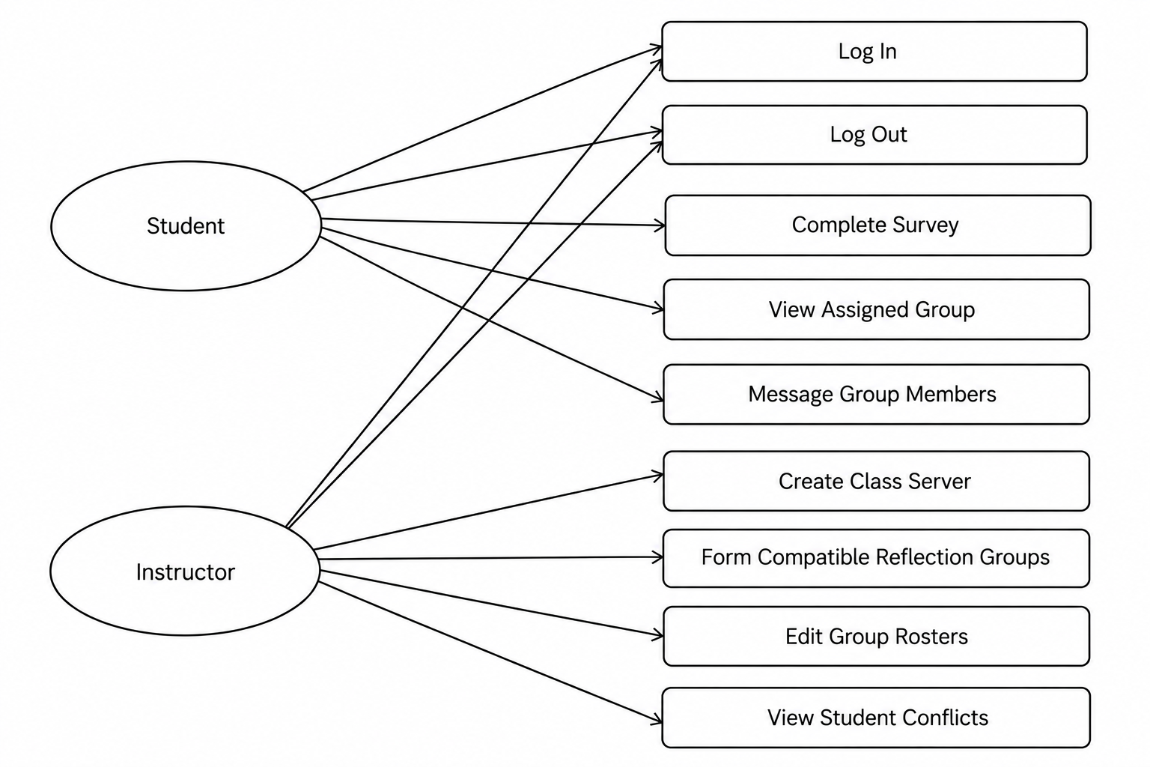

Teacher

Teacher System

Log in
Log Out
View all Groups
Add/Remove Group Members
Assign Personality Quiz

Student

Student System

Log in
Log Out
Take Personality quiz/survey
View Profiles
View Group

